
CSA15 Cloud Computing and Big Data Analytics
CO1 AT2 - Digital Concept Map and Service Model Matrix
Individual Student Submission Template

Student and Faculty Details
Student Name | K.DHEEPAK | Register Number | 192411108
Class / Section | T16-W01-R15 | Slot | C
Course Code | CSA1517 | Course Title | Cloud computing
Capstone Title | Cloud fram co-op platform with shared equipment booking and utilization analytics
Submission Date | 10/7/2026
Faculty Name | DR.Rajasbabu | Employee ID
Department | BE-CSE

Assessment Brief
Course Outcome | CO1 - Explain the evolution, architecture, characteristics, service models, and emerging paradigms of cloud computing.
Assessment Type | Individual concept mapping, service-model responsibility analysis, and capstone-cloud interpretation.
Assessment Focus | Each map must show key nodes, link labels, relationship meaning, and a logical hierarchy. The response must connect cloud fundamentals to the student's own perception of the capstone title.
Submission Mode | Editable DOCX + exported diagram evidence + GitHub repository link submitted in Google Classroom.
Permitted Tools | draw.io / diagrams.net, Lucidchart, Miro, Canva, PowerPoint, Google Drawings, or equivalent diagramming tool.
Individual Rule | Every student must submit their own concept map, matrix, capstone-cloud mapping, and reflection. The capstone title may be shared by a team, but the assessment answer must not be common.
Total Marks | 100 marks

Code of Conduct and Student Assurance
Academic Integrity Statement
This assessment must be completed individually. Students may discuss the capstone domain with their team, but the concept map, service model matrix, explanations, GitHub evidence, and reflection submitted here must be individually prepared.
Student Assurance | I confirm that this submission represents my own understanding of CO1 concepts and my individual interpretation of the selected capstone title.
Tool Use | I have used digital tools only for diagram preparation, organization, and presentation. I have not copied another student's diagram, matrix, or explanation.
Evidence | I have uploaded the required files to my GitHub repository and submitted the repository link / evidence link through Google Classroom.
Student Signature | abishek
Date | 10/07/2026

Procedure for Preparing the Digital Concept Map
Use the following procedure to prepare the diagram and upload evidence. Students who already know another diagramming tool may use it, but the exported evidence and source file must still be submitted.
- Open https://app.diagrams.net/ or the desktop version of draw.io / diagrams.net.
- Choose Device, Google Drive, or OneDrive as the save location according to availability.
- Create a blank diagram and name the file as CSA15_CO1_AT2_RegisterNumber_Concept_Map.drawio.
- Place the capstone title at the center or as a clearly visible anchor node.
- Add major cloud nodes: cloud definition, cloud evolution, cloud architecture, service models, deployment models, virtualization, web services, SOAP, REST, APIs, elasticity, scalability, resource pooling, measured service, and emerging paradigms.
- Connect nodes with labeled arrows such as uses, depends on, enables, scales through, communicates through, belongs to, supports, provides, consumes, or controls.
- Use colors meaningfully: one color for service models, one for cloud characteristics, one for API/web-service concepts, and one for capstone-specific elements.
- Export the final diagram as PNG or PDF. Keep the editable .drawio source file also.
- Paste the exported diagram image or screenshot in this DOCX under Task 1.
- Upload the DOCX, exported PNG/PDF, and .drawio file to GitHub, then submit the GitHub link in Google Classroom.

GitHub Submission Procedure
Step | Required Action | Expected Evidence
1 | Create or use your individual GitHub account. | GitHub profile link.
2 | Create a repository named  CSA15-CO-Assessments-RegisterNumber or use the repository instructed by faculty. | Repository URL.
3 | Create a folder named CO1_AT2 inside the repository. | Folder visible in repository.
4 | Upload this completed DOCX, exported diagram PNG/PDF, and editable .drawio source file. | At least three evidence files uploaded.
5 | Add a short README.md explaining the capstone title and files submitted. | README visible in the AT2 folder.
6 | Submit the GitHub folder link in Google Classroom. | GCR submission with repository/folder link.

Assessment Questions and Student Response Sections
Important
The capstone project may be developed by a team, but every response below must be written from the individual student's own perspective. Do not submit a common team answer.

Task 1 - Digital Cloud Concept Map
Create one integrated digital concept map for CO1. The map must show key nodes, link labels, relationship meaning, and a logical hierarchy. It must also connect the concepts to your selected capstone title from your
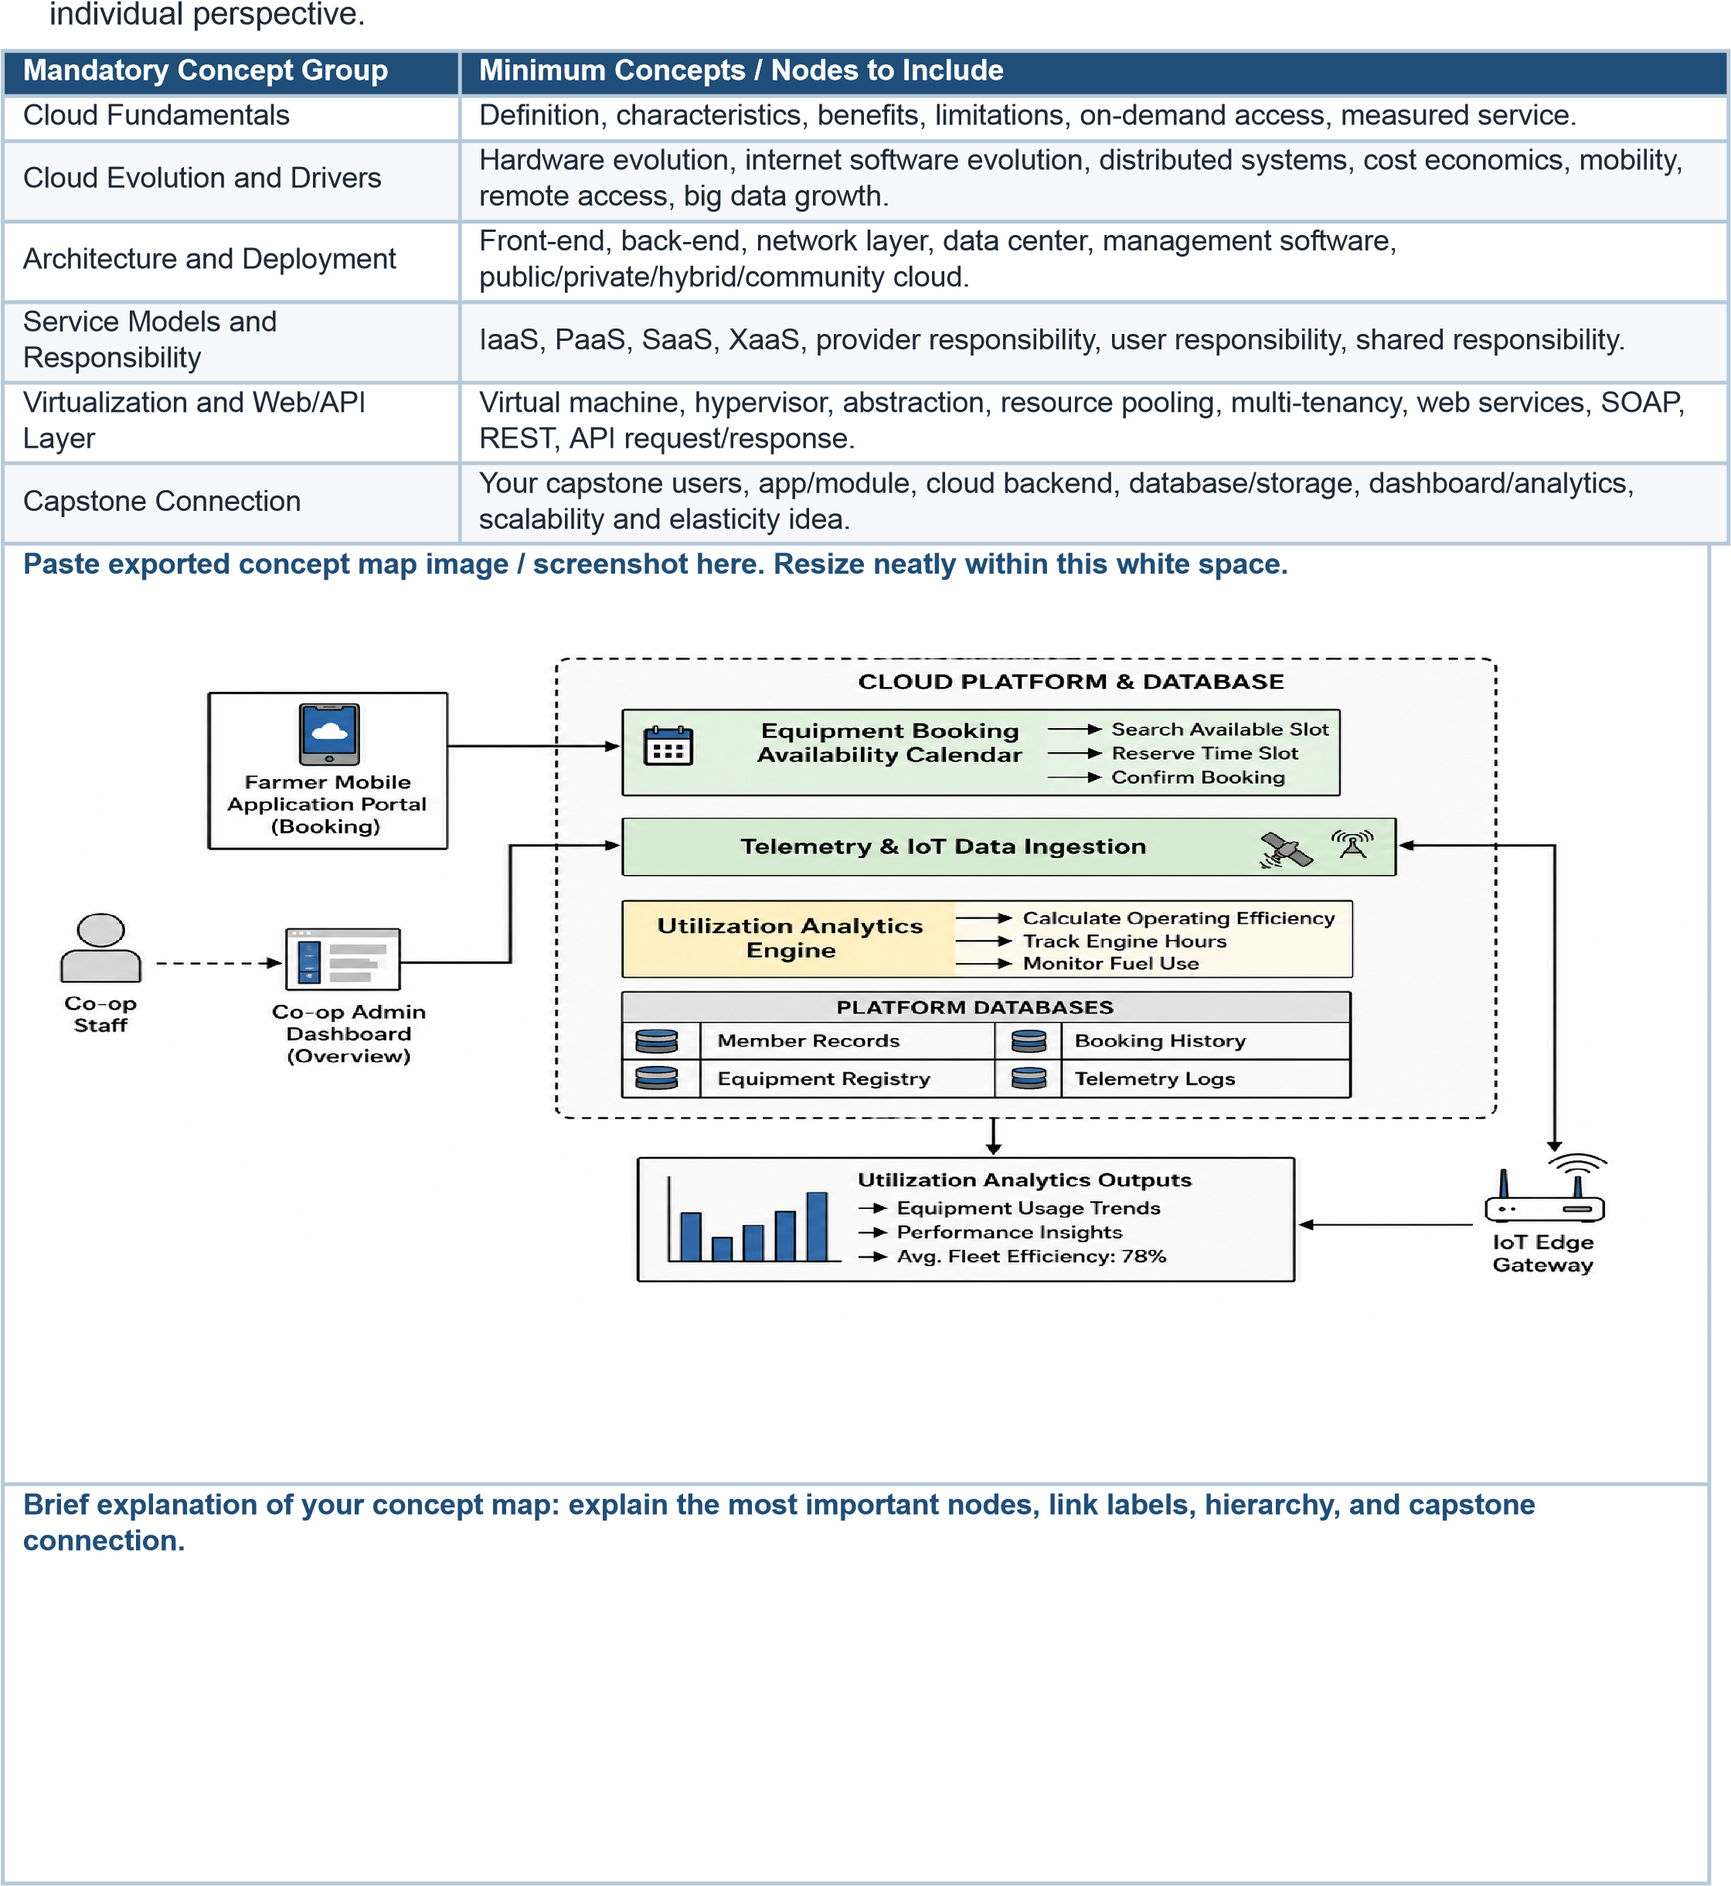

Task 2 - Service Model Matrix
Complete the matrices by making technical decisions for your capstone project. Select only the rows that are relevant to your capstone design. If a row is not used, write a short technical reason instead of leaving it blank.
Your answer should show how responsibility shifts between cloud provider and student development team, and how the chosen services support the capstone workflow, API design, storage, security, scalability, and evidence submission.
Task 2A - Service Model Responsibility Matrix
Service Model | Capstone Role / Module | Provider  Responsibility | Student  Responsibility | Evidence to Submit
IaaS | Virtual Machine &  Network | Provides virtual servers, storage and networking | Deploy and configure application | VM Screenshot
PaaS | Backend API &  Application | Manages runtime,  OS and scaling | Develop application logic and APIs | API  Screenshot/Code
SaaS | Authentication  (Google/Firebase  Auth) | Provides login service and user management | Configure authentication and roles | Login Screenshot
XaaS /  Specialized  Service | Maps/Notification  API | Provides API services | Integrate API into application | API Integration  Screenshot
Task 2B - Capstone Cloud Service Decision Matrix
Cloud Layer / Function |  | Selected Tool or Service | Data / Resource Handled | API or Integration Path | Security / Scaling Note
Client access and UI |  | React / HTML-CSS | Booking requests | HTTPS REST API | Secure Login
API / backend logic |  | React /  HTML-CSSReact /  HTML-CSS | Booking requests | HTTPS REST API | Secure Login
Authentication and identity |  | API / Backend  Logic | node.js / Express | Booking processing | /book, /cancel, /availabilit y
Database / structured records |  | Firebase  Authentication | User Login | Firebase Auth API | JWT Authentication
File / object storage |  | Firebase Firestore /  MySQL | User & Booking  Data | CRUD APIs | Role-based Access
Monitoring / logs / usage metrics |  | Firebase Analytics | App Usage | Analytics SDK | Performance Monitoring
Analytics / reporting output |  | Power BI / Firebase  Analytics | Booking Reports | Dashboard API | Read-only Reports
Technical justification: Explain why the selected cloud service pattern fits your capstone project's users, data, API flow, scalability, and security needs.
Task 2A: Shared Equipment Booking System
- Objective: A cloud calendar that lets cooperative members schedule and share high-cost machinery seamlessly.
- Core Features: o Dynamic Calendaring: Real-time visibility of available equipment filtered by location and crop phase. o Conflict Resolution: Automated rules that fairly allocate machinery during peak harvest windows. o Smart Access: Generates mobile digital keys to unlock equipment only during the approved booking time.
Task 2B: Utilization Analytics & Maintenance
- Objective: Uses IoT data to track fleet health, optimize fuel efficiency, and prevent breakdowns.
- Core Features: o Efficiency Dashboards: Tracks engine load hours, fuel burn, and acres covered to calculate asset productivity.
o | Predictive Maintenance: Monitors live sensors (temperature, pressure) to catch mechanical issues early.
o | Auto-Scheduling: Instantly pulls damaged machines from the booking pool and alerts the mechanic.Core Features:
o | Dynamic Calendaring: Real-time visibility of available equipment filtered by location and crop phase.
o | Conflict Resolution: Automated rules that fairly allocate mac

Task 3 - Capstone Cloud Flow Mapping
Study the sample architecture-flow template below. Redraw it in draw.io / diagrams.net using your own capstone architecture. Replace every generic label with your actual user role, screen, API endpoint, backend logic, cloud storage, analytics output, security control, and scalability or elasticity decision.
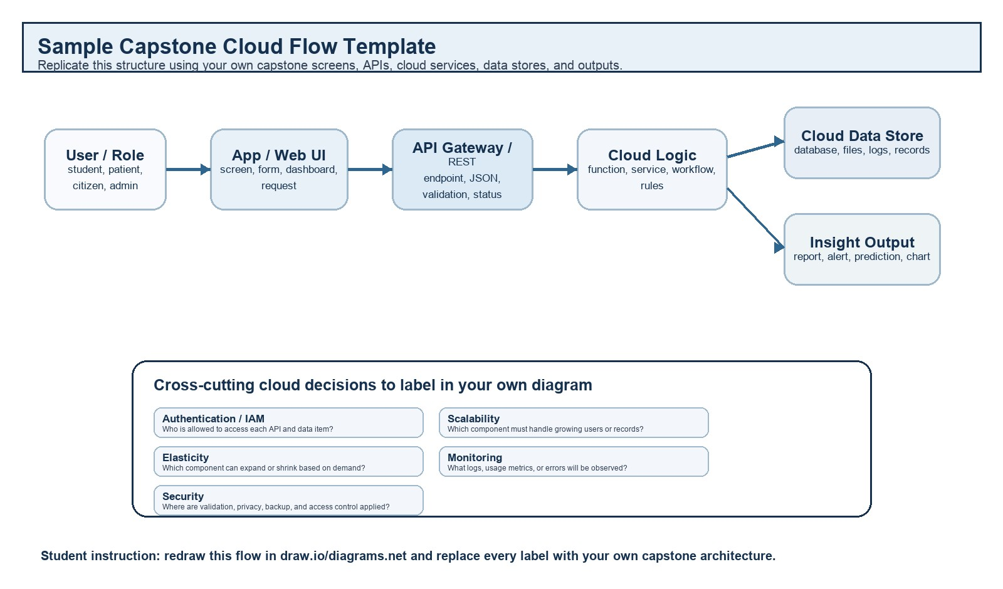
Student Drawing Requirement
Do not copy the sample as it is. Use it as a layout model, then create your own capstone-specific flow diagram with meaningful labels, arrows, data movement, API names, and cloud service choices.
 | Flow Component | Student Entry
 | User role and action | Student, Teacher, Admin – Login and access dashboard
 | Frontend / app screen | Web Application / Dashboard
 | API endpoint and method | POST /login, GET /student-data, POST /predict
 | Backend processing rule | Validate user → Process data → Run ML model → Store results
 | Cloud database / storage operation | Store student records, prediction results, reports
 | Response, alert, report, or dashboard output | Performance prediction, graphs, alerts, reports
 | Security, scalability, and  elasticity labels added in diagram | Authentication, HTTPS, Auto Scaling, Cloud Monitoring
 | Paste your redrawn capstone cloud-flow diagram here.
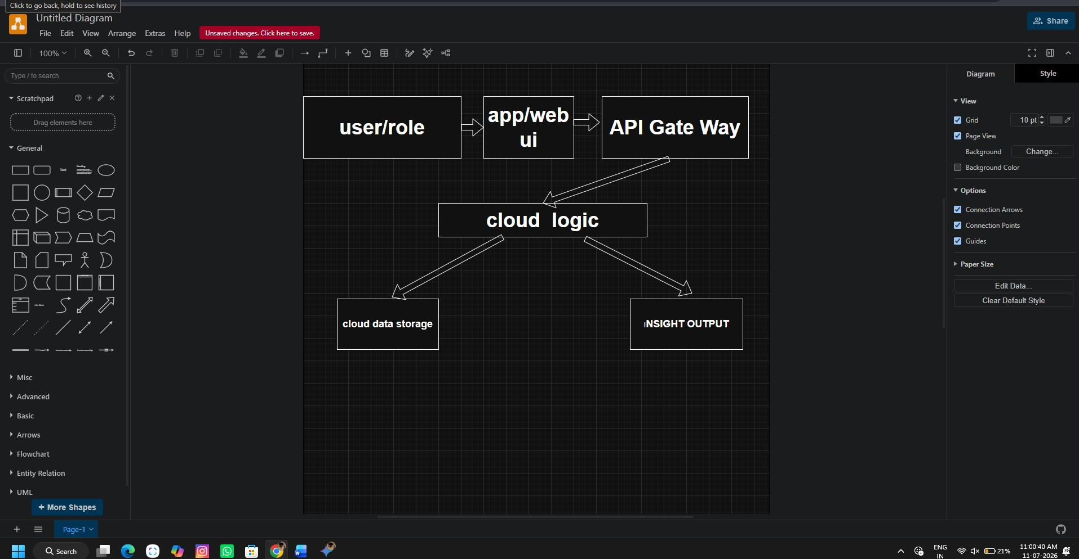
Brief explanation: explain one complete request-response path from user action to cloud response.

Task 4 - Individual Reflection
Answer the following from your own perspective. Avoid team-common wording.
1. What is the strongest cloud concept represented in your capstone project?
The strongest cloud concept in my capstone project is cloud storage and data management. I understood how cloud platforms help store, access, and manage data securely from anywhere while improving reliability and availability.
2. Where will elasticity or scalability become important in your capstone product?
Elasticity and scalability become important when the number of users increases. The cloud can automatically provide more resources during high traffic and reduce them when demand is low, ensuring smooth performance and cost efficiency.
3. Which API or web-service idea is most relevant to your project and why?
A REST API is the most relevant because it allows the frontend and backend to communicate efficiently. It helps exchange data securely and makes the application easier to integrate with other services in the future.
4. What did you personally understand better after preparing this concept map and matrix?
After preparing the concept map and matrix, I gained a better understanding of how different cloud concepts are connected. It helped me identify the right cloud services for my project and understand how they improve performance, scalability, and security.

Evaluation Rubric - 100 Marks
Criteria | Marks | Expected Standard
Concept identification | 20 | Major CO1 concepts are accurately identified: cloud fundamentals, characteristics, evolution, service models, deployment models, virtualization, web services, SOAP/REST, APIs, elasticity, and scalability.
Relationship mapping | 20 | Links between concepts are accurate, meaningful, and labeled. The map should explain how concepts depend on, enable, consume, provide, scale, or control one another.
Hierarchy and organization | 15 | Concepts are arranged in a logical hierarchy with clear grouping, readable flow, and no disconnected keyword clusters.
Technical relevance | 15 | The map strongly reflects cloud course content and avoids decorative or generic non-technical content.
Service model matrix | 15 | IaaS, PaaS, SaaS, and XaaS are compared with provider responsibility, user responsibility, examples, capstone usage, and risks or limitations.
Capstone alignment and individual reflection | 10 | The student's own capstone interpretation is visible in the concept map, flow mapping, justification, and reflection. Team-common answers are avoided.
Visual clarity and digital evidence | 5 | Diagram is neat, readable, exported properly, and supported with GitHub evidence including source and exported files.

Faculty Evaluation Record
Evaluator Name |  | Marks Awarded
Observation |  | Signature

